

**PROJECT REPORT**

O**n**

Fee Billing System

**SUBMITTED BY**

**NAME : ABHISHEK PAL**

**UNIVERSITY ROLL No: 201500013**

**CLASS ROLL No : 02**

Department of Computer Engineering

& Applications

**Institute Of Engineering & Technology**

**GLA University Mathura – 281406**



Declaration

I hereby declare that the work which is being presented in the Project Report “ **Title – Fee Billing System “,** in partial fulfillment of the requirements for the Project in an authentic record of my own work carried under the supervision of **Mrs ANUPAM YADAV , Assistant Professor, GLA University ,Mathura.**

Sign

Name Of Candidate :

University Roll no:

|  |  |  |  |
| --- | --- | --- | --- |
| Sign |  |  |  |
| Name Of Candidate : | | **Certificate** |  |
| University Roll no: | |  |
|  |  |

This is to certify that the above statements made by the candidate areSigncorrect to the best of my/our knowledge and belief.

Name Of Candidate :

University Roll no:

________________

**Project Supervisor**

Mr/Ms.

Designation of Supervisor

Date:

**Certificate**

This is to certify that the above statement made by the candidate are correct to the best of my/our knowledge and belief.

**Project Supervisor**

MrzMrs Anupam Yadav

Designation of Supervisor

Date:



**TABLE OF CONTENTS**

* 1. Introduction

1. Proposed system
   * 1. Description
     2. System requirements
2. Requirement Analysis
3. System Design
4. Flow Chart
5. Source Code
6. Future Scope of the Project
7. Conclusion

**INTRODUCTION**

In the existing system, most of the records are maintained on paper. It becomes very inconvenient to modify the data. In the existing system, here is a possibility that the same data in different registers may have different values which means the entries of the same data do not match. This inconsistent state does not supply the concrete information which poses a problem in the case information related to particular search record.

Our project is very useful. User is no longer required to check his register in search of records, as now it can be searched over the software by choosing some options. The user need not to type in most of the information. He/she is just required to enter the desired options. On the whole it liberates the user from keeping lengthy manual records. In a nutshell, it abates the work load of an organization.

In today’s world, no one likes to perform calculations on calculator or manually when computer is there. Every one wants his/her work to be done

by computer automatically and displaying the result for further manipulations. So this project is about providing convenience regarding fee management system.

**PROPOSED SYSTEM**

The following documentation is a project the “FEE BILLING SYSTEM”. It is a detailed summary of all the drawbacks of the old system and how the new proposed system overcomes these shortcomings. The new system takes into account the various factors while designing a new system. It keeps into the account the Economical bandwidth available for the new system. The foremost thing that is taken care of is the need and requirements of the user.

**DESCRIPTION**

Before developing software we keep following things in mind that we can develop powerful and quality software.

**PROBLEM STATEMENT**

Problem statement was to design a module:

1. Which is user friendly
2. Which will restrict the user from accessing other user’s data. o Which will help user in viewing his data and privileges.

o Which will help the administrator to handle all the changes.

**FUNCTIONS TO BE PROVIDED:**

The system will be user friendly and completely menu driven so that the users shall have no problem in using all options.

1. The system will be efficient and fast in response. o The system will be customized according to needs.

FOR FEE MANAGEMENT SYSTEM o (View

o Add

o Delete)

**SYSTEM REQUIRMENTS**

Operating system: MS Windows XP or Windows Vista

Language: C Language

Processor: Pentium IV Processor

RAM: 512 MB

Hard disk: 5 GB

**REQUIREMENT ANALYSIS**

This process is adopted when management of the system development, Personnel decide that the particular system needs improvement. The system development life cycle is the set of activities, carried out by the analyst, designers and users to develop and implement a system. The systems that are present in the nature follow common life cycle pattern. For example consider the raining system. Initially the rain falls into the river, river flows into sea, the sea water evaporates to form vapors, the vapors form clouds which again bring rain. Similarly consider a man made system initially a system is analyzed, designed and made operational by the efforts of system analysis.

After successful operation or a number of users, the system becomes less and less effective by change in the environment. So these changes have to be incorporated in to the system by minor modifications. So the general activities from the life cycle of the system are given below:

* Select ion and identification of the system to be studied
* Preliminary study
* Defining the system
* Design and development of the system
* Implementation of the system

**SYSTEM DESIGN**

Then we began with the design phase of the system. System design is a solution, a “HOW TO” approach to the creation of a new system. It translates system requirements into ways by which they can be made operational. It is a translational from a user oriented document to a document oriented programmers. For that, it provides the understanding and procedural details necessary for the implementation. Here we use Flowchart to supplement the working of the new system. The system thus made should be reliable, durable and above all should have least possible maintenance costs. It should overcome all the drawbacks of the Old existing system and most important of all meet the user requirements.

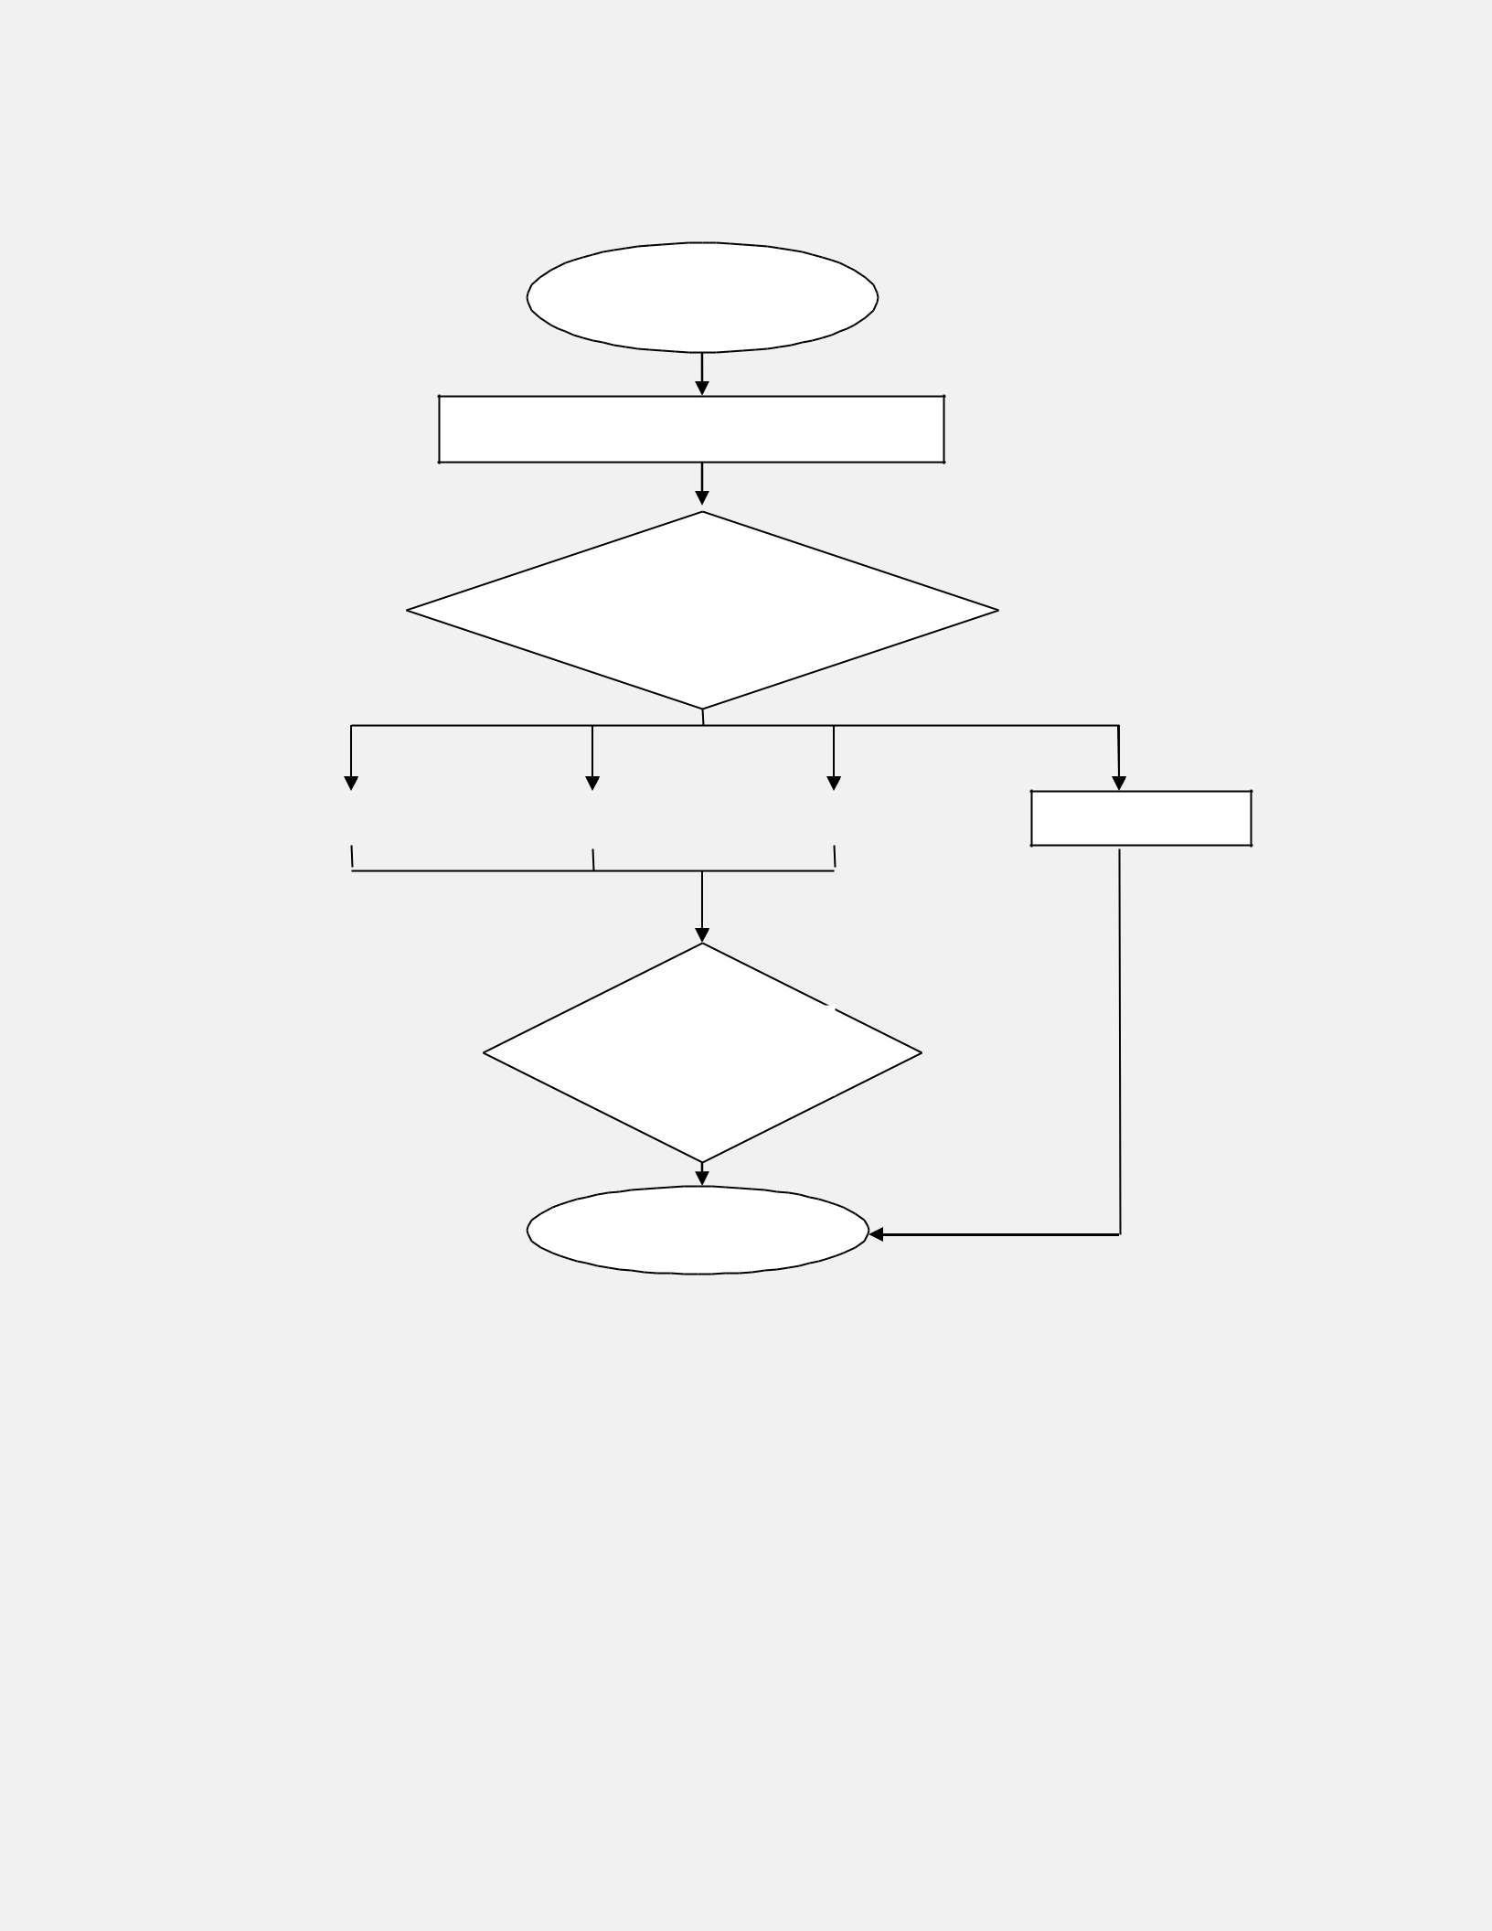**FLOW CHART**

START

WELCOME TO MAIN MENU

Enter your

choice

|  |  |  |  |  |
| --- | --- | --- | --- | --- |
| Student detail |  | Create new account |  | Collect the fees |
|  |  |  |  |  |

Do you want

to continue?

STOP

Quit



**SOURCE CODE**

*//Student fee record*

*#include<stdio.h>*

*#include<conio.h>*

*void main()*

*{*

*FILE *fp, *ft;*

*char another, choice;*

*struct fee*

*{ int r_no; char name[40]; char add[40]; char f_name[40]; char stream[40];*

*long int d_fee;*

*};*

*struct fee f;*

*long int amount,flag;*

*long int total=2000;*

*long int pending=0;*

*long int recsize;*

*char stream[40];*

*int r_no;*

*fp=fopen("FEE2.DAT","rb+");*

*if(fp==NULL)*

*{*

*fp=fopen("FEE2.DAT","wb+");*

*if(fp==NULL)*

*{*

*puts("Cannot open file");*

*exit(1);*

*}*

*}*



*recsize = sizeof(f);*

*while(1)*

*{*

*clrscr();*

*gotoxy(30,10);*

*printf("1. Student detail");*

*gotoxy(30,12);*

*printf("2. Display Record");*

*gotoxy(30,14);*

*printf("3. deposite fee");*

*gotoxy(30,16);*

*printf("4. Pending fee");*

*gotoxy(30,18);*

*printf("5. Delete Record");*

*gotoxy(30,20);*

*printf("0.Exit");*

*gotoxy(30,22);*

*printf("Your choice");*

*fflush(stdin);*

*choice = getche();*

*switch(choice)*

*{*

*case '1':*

*fseek(fp,0,SEEK_END);*

*another = 'Y';*

*while((another == 'Y') || (another == 'y'))*

*{*

*printf("\nEnter Roll_no");*

*scanf("%d", &f.r_no);*

*printf("\nEnter Name");*

*scanf(" %s",f.name);*

*printf("\nEnter Address");*

*scanf("%s",f.add);*

*printf("\nEnter Father name");*

*scanf("%s",f.f_name);*

*printf("\nEnter deposited fee");*

*scanf("%ld", &f.d_fee);*

*printf("\nEnter Stream");*

*scanf("%s",f.stream);*

*fwrite(&f, recsize, 1, fp);*

*printf("\nCreate another Student Record(Y/N)");*

*fflush(stdin);*

*another = getche();*

*}*

*break;*

*case '2':*

*clrscr();*

*rewind(fp);*

*printf("Roll no\tname\tAddress\tFather name\tStream\tdeposited fee\tTotal amount"); while(fread(&f, recsize, 1, fp) == 1)*

*printf("\n%d\t%s\t%s\t%s\t%s\t%ld\t%ld", f.r_no,f.name, f.add, f.f_name,f.stream, f.d_fee,total);*

*getch();*

*break;*

*case '3':*

*another='Y';*

*while(another=='Y')*

*{*

*printf("\nEnter Roll number to check balance");*

*scanf("%d",&r_no);*

*printf("\nEnter the Stream");*

*scanf("%s",stream);*

*rewind(fp);*

*flag=0;*

*while(fread(&f, recsize, 1, fp)==1)*

*{*

*if((f.r_no==r_no)&&(strcmp(f.stream,stream)==0))*

*{*

*if(f.d_fee<=total)*

*{*

*flag=1;*

*printf("\nEnter amount to deposite");*

*scanf("%ld",&amount);*

*f.d_fee=f.d_fee + amount;*

*fseek(fp, -recsize, SEEK_CUR);*

*fwrite(&f,recsize,1,fp);*

*break;*

*}*

*}}*

*if(flag==0)*

*{*

*printf("sorry !! invalid rollno");*

*getch();*

*}*

*printf("deposite more amount");*

*fflush(stdin);*

*another=getche();*

*}*

*break;*

*case '4':*

*another='Y';*

*while(another=='Y')*

*{*

*printf("\nEnter roll number to check pending amount");*

*scanf("%d",&r_no);*

*printf("\nEnter the Stream");*

*scanf("%s",stream);*

*rewind(fp);*

*flag=0;*

*while(fread(&f, recsize, 1, fp)==1)*

*{*

*flag=1;*

*if((f.r_no==r_no)&&(strcmp(f.stream,stream)==0))*

*{*

*pending=total-f.d_fee;*

*printf("\nYour pending amount is %ld",pending);*

*f.d_fee=f.d_fee+pending;*

*getch();*

*}*

*}*

*if(flag==0)*

*{*

*printf("Sorry !! Invalid roll number");*

*getch();*

*}*

*fflush(stdin);*

*another=getche();*

*}*

*break;*

*case '5':*

*another='Y';*

*while(another=='Y')*

*{*

*printf("\nEnter roll number to delete");*

*scanf("%d",&r_no);*

*ft = fopen("TEMP.DAT","wb");*

*rewind(fp);*

*while(fread(&f, recsize, 1, fp) == 1)*

*{*

*if(f.r_no!=r_no)*

*fwrite(&f, recsize, 1, fp);*

*}*

*fclose(fp);*

*fclose(ft);*

*remove("FEE2.DAT");*

*rename("TEMP.DAT", "FEE2.DAT");*

*fp=fopen("FEE2.DAT", "rb+");*

*printf("Delete another record(Y/N)");*

*fflush(stdin);*

*another = getche();*

*}*

*break;*

*case '0':*

*fclose(fp);*

*exit();*

*}*

*}}*

**FUTURE SCOPE OF THE PROJECT**

My project “FEE BILLING SYSTEM” will be able to implement in future after making some changes and modifications as we make our project at a very low level. So the modifications that can be done in our project is to add one major change which can be done in this project is thatto add the snaps of the student of which the record is entered. This will result in total identification of the given student. Similarly various modifications can be done to enhance the usability of the given project as suitable for user’s requirement.

**CONCLUSION**

From this project we can conclude that if this program is very useful in fee management as it provides more convenience than the manual work. It provides easy methods to manage the load of work easily for the users. It is much fast and more efficient as the data once entered can be modified and accessed easily. The program can be used per the requirement of the user as it is very easy to understand.